**CPSC 6109:** [**Advanced**](https://colstate.view.usg.edu/d2l/lp/ouHome/home.d2l?ou=1218642) **Algorithms**

**Spring 2018**

**Student: Lu Lin**

**Assignment #7**

**Due: 11:59 PM Sunday, April 15**

Do the following exercises/problems. Each problem is worth 50 points with a total of 100 points.

1. Exercise **22.2-2** on page 601 (Show the d and π values that result from running breadth-first search on the undirected graph on Figure 22.3, using vertex ***u*** as the source) by using the vertex ***t*** as the source vertex (instead of using the vertex ***u*** as the source).

Solution:

As Figure 22.3 shows, I use vertex t as the source vertex.

1. t as source vertex, I color t as grey.

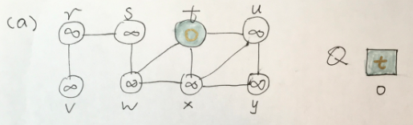

1. vertex w, x, u are discovered and are colored as grey; source vertex t is colored pink. Tree edges are shaded as they are produced by BFS. Vertex distances appear both in circle and below vertices in the queue.

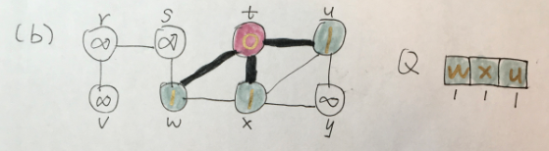

1. new vertex s and new tree edge are discovered: vertex s is colored as grey and its vertex distance is 2, vertex w is colored as pink. New tree edge is shaded as shown in textbook.

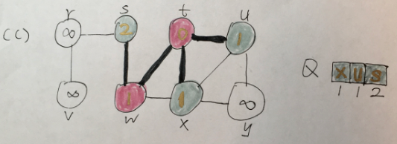

1. new vertex y and new tree edge are discovered and treated as previous steps

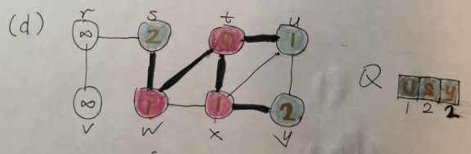

1. no new vertex and edge and vertex u is colored from grey to pink.

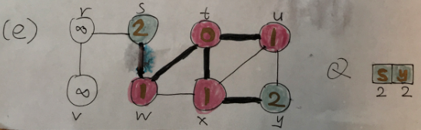

1. new vertex r and new tree edge are discovered and treated as previously.

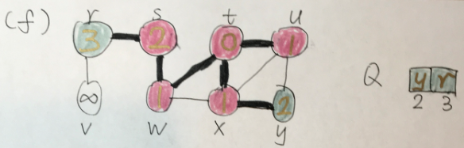

1. no new vertex and edge and vertex y is colored from grey to pink.

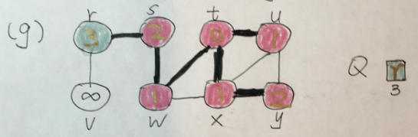

1. new vertex v and edge are discovered and treated as previously.

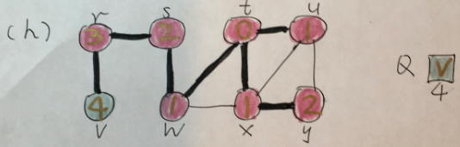

1. vertex v is colored from grey to pink.

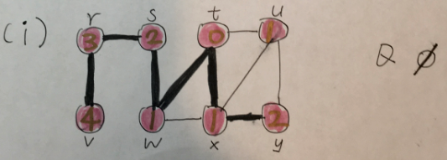

The procedure of the BFS is shown above. From the result, we can see that:

|  |  |  |
| --- | --- | --- |
| Node | d | π |
| t | 0 | NIL |
| w | 1 | t |
| x | 1 | t |
| u | 1 | t |
| s | 2 | w |
| y | 2 | x |
| r | 3 | s |
| v | 4 | r |

1. Show how depth-first search works on the graph given below using the vertex ***D*** as the original source vertex. Assume that the for-loop of lines 5–7 of the DFS procedure (on page 604) considers the vertices in alphabetical order, and assume that each adjacency list is ordered alphabetically. ***You must show the discovery and finishing times for each vertex, and show the classification of each edge***.

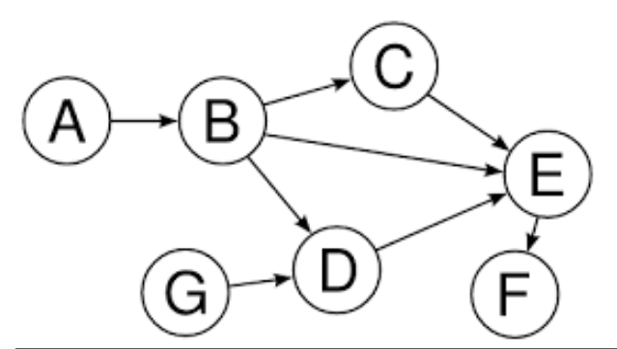

Solution:

1. Source vertex D is assigned a discovery time (u.d) 1 and is painted grey.

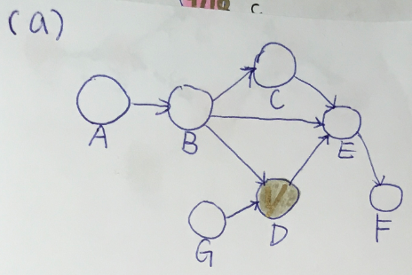

1. Tree edge (D, E) is discovered and is painted by shaded black line. Vertex E is assigned a discovery time 2 and is painted grey.

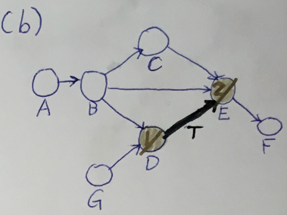

1. Tree edge (E, F) is discovered and is painted shaded black line. Vertex F is assigned a discovery time 3 and is painted as grey.

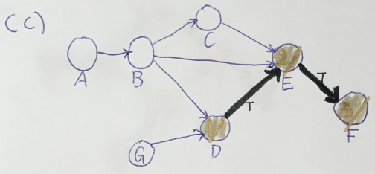

1. Vertex F is painted as pink, and record the finishing time as 4.

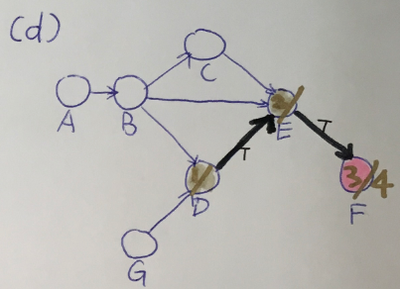

1. Vertex E is painted as pink, and record the finishing time 5.

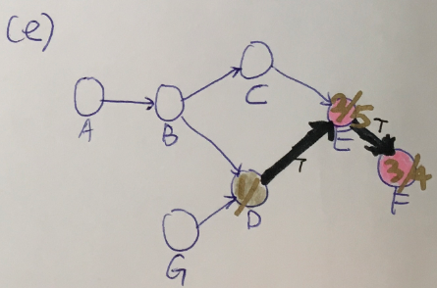

1. Vertex D is painted from grey to pink, and record the finishing time 6.

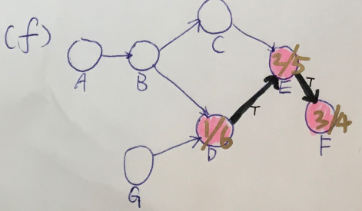

1. Vertex A becomes the root of a new tree in the depth-first forest and is painted grey. The discovery time is 7.

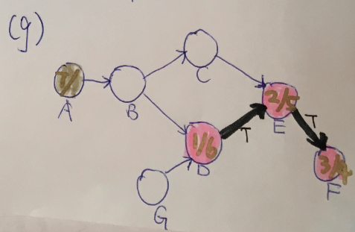

1. Tree edge (A, B) is discovered and is paint shaded black line. Vertex B is discovered and the discovering time is 8.

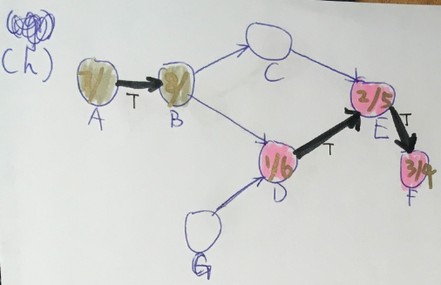

1. Tree edge (B, C) is discovered and is paint shaded black line. Vertex C is discovered and the discovering time is 9.

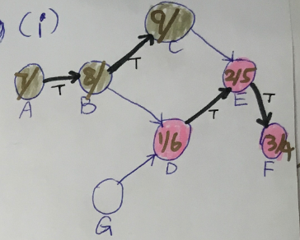

1. Nontree edge (C, E) is labeled C according to it is cross edge.

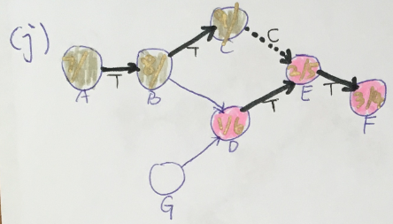

1. Vertex C is painted pink because it’s been explored. The finishing time is 10.

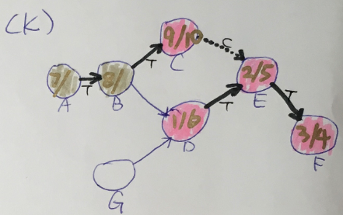

1. Nontree edge (B, D) is labeled C according to it is a cross edge.

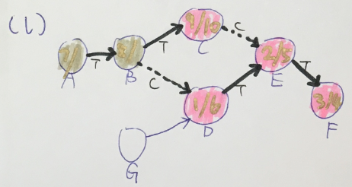

1. Vertex B is painted from grey to pink because it’s been explored. The finishing time is 11.

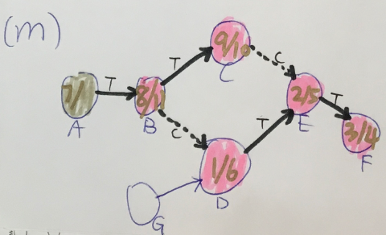

1. Vertex A is painted from grey to pink because it’s been explored. The finishing time is 12.

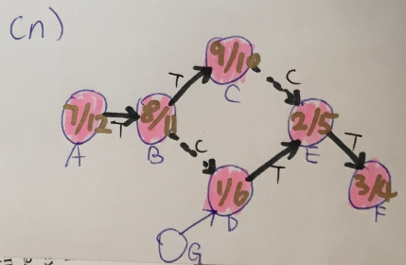

1. Vertex G becomes the root of a new tree in the depth-first forest and is painted grey. The discovery time is 13.

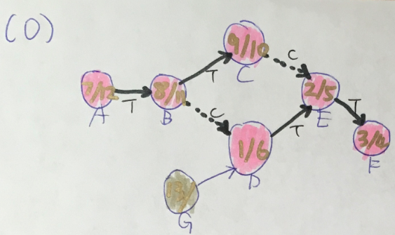

1. Tree edge (G, D) is discovered and is paint shaded black line. 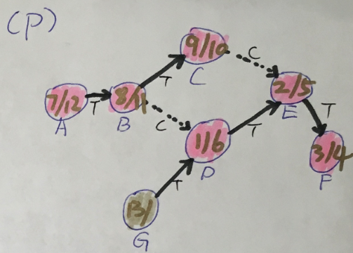
2. Vertex G is painted from grey to pink, the finishing time is 14.

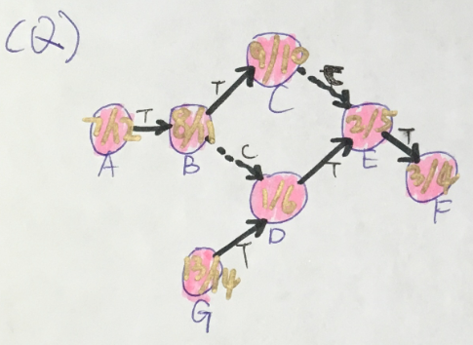

The discovery time u.d and finishing time u.f of every vertex u are as following:

|  |  |  |
| --- | --- | --- |
|  | u.d | u.f |
| D | 1 | 6 |
| E | 2 | 5 |
| F | 3 | 4 |
| A | 7 | 12 |
| B | 8 | 11 |
| C | 9 | 10 |
| G | 13 | 14 |

Tree edges: (D, E), (E, F), (A, B), (B, C), (G, D)

Cross edges: (C, E), (B, C)